IKEA Married with White

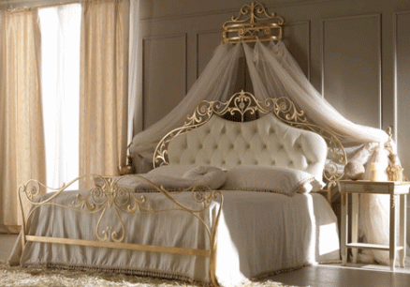

|  |
| --- |
| **DESCRIPTION** |
| IKEA introduces steel bed with a rust free zinc chromium ferrate. This set of bed is sure to create the beautiful look in any home. The rich royal designed bed is perfect for comfort level as it holds state of the art water mattress technology. Perfect for relaxation and a tension free nap. With its height it will manage to create a beauty with curiosity and its hard form attached with metal head makes it easy for you to sit upright. |

|  |  |  |
| --- | --- | --- |
| **Price** | **3400$** | |
| **Dimensions** | **H** x **W** x **L** | **28in x 60in x 75in** |
| **Features** | **Two pillows and a curtain top enhance the strength and beauty of this bed and stainless steel makes it perfect for beach areas.** | |
| **Finished** | **Golden Natural Electrolysis** | |
| **Available in** | **Gold and Silver** | |